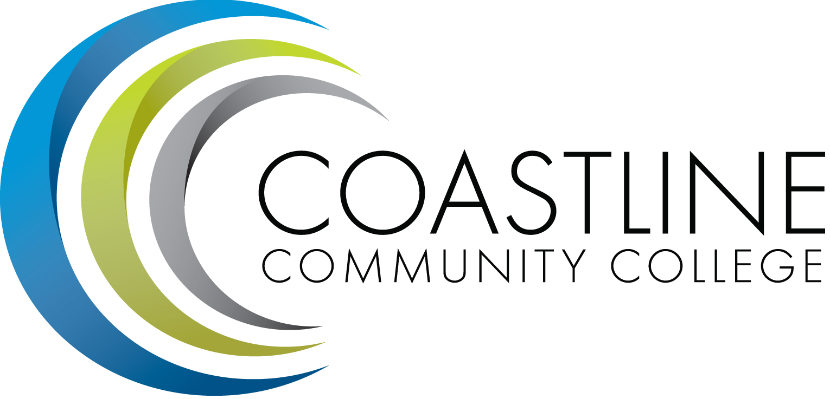

College Professional Development & Leadership Committee Agenda
09/05/2017
3:00 pm to 5:00 pm
College Center, Distance Learning Conference Room

CALL TO ORDER
Present | Members
 | Blair, Shelly, Co-Chair, Dean of Innovative Learning
 | Chapman, Cheryl, Co-Chair, Academic Senate Representative
 | Akins, Renate, HR & AANAPISI Diversity Working Group Representative
 | Garvey, Judy, Marketing Manager Representative
ABS | Harrison, Nate, Extended Learning Manager Representative
 | Hipp Mirhashemi, Kasie, Classified Senate Representative
 | Holliday, Ann, Academic Senate Representative
 | Lee, Lisa, Academic Senate Representative
 | Leighton, Ken, Academic Senate Representative
 | Lockwood, Rick, Academic Senate Representative
 | Mensah, Araba, Classified Senate Representative
ABS | Warwick, Randall, Academic Senate Representative
 | Worden, Mark, Classified Senate Representative
 | McCollom, Dorothy, Recorder

  - Welcome
  - Adoption of Agenda
  - Approval of Minutes: 05/02/2017

REPORTS
  - None

DISCUSSION
  - Professional Development Strategic Plan – Shelly
  - Goals for 2017-2018 - Shelly
  - Summer Institute 2018 Dates - Shelly

ACTION
  - None

STANDING REPORTS
  - None

ANNOUNCEMENTS
  - Next Meeting, October 3, 2017 at 3:00 pm

ADJOURNMENT

